Face Trial 1
Appendix

Online conversion methods will convert mobile phone recorded videos which are in .mp4 format to .avi to be imported into ImageJ. However, the compression of the videos involved in this process is unsupported and the final video will not be able to be imported into ImageJ. (fijis built in avi reader is very old)
Therfore the best way to convert .mp4 to .avi is through ffmpeg. Ffmpeg is an a free and open-source software project that is a powerful suite of libraries and tools for handling multimedia files. It must be downloaded and opened in the command panel (for windows)
After downloaded and extracted ffmpeg needs to be added to the path. From
WIN+R
opening sysdm.cpl
advanced
environment variables
system variables
path
edit
new
add
C:\ffmpeg\bin
Ok
Test this by writing ffmpeg -version into the command prompt , if the version information is printed ffmpeg is ready to be used
The video to be converted should be added to the ‘bin’ file within the ffmpeg file. The command should then be ran within the bin folder by shift and right clicking open powershell window here inside the folder.
Once in the powershell command window print
ffmpeg -i "facetry2-ideal...Trim22411.mp4" -vcodec mjpeg -qscale:v 2 output_mjpeg.avi
where "facetry2-ideal...Trim22411.mp4" is the input video name, with .mp4 included.
Once converted the output video will also be in the bin file.

To export into imageJ, open Fiji go to file – open and choose output file , video will load as a stack (each frame becomes a slice)
Select ROI using rectangle or oval selection tool
OPTIONAL STABILIZE THE VIDEO
Plugins → Registration → StackReg
Rigid Body

Then split the colour channels, pulse is strongest in green
Image – Colour – Split Channels , use the green stack
With ROI still drawn
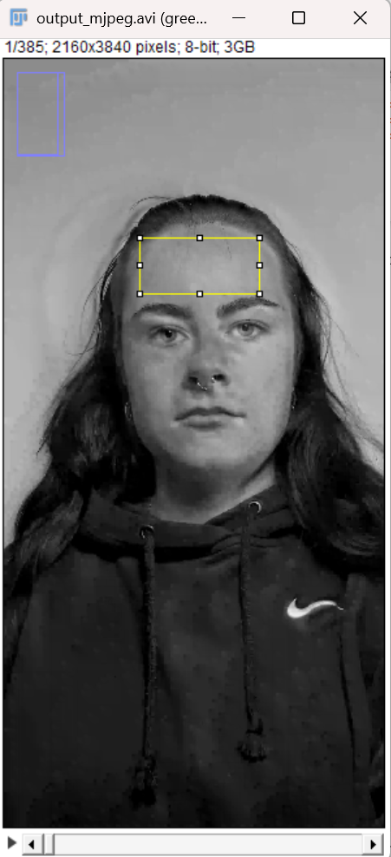
Image – Stacks – Plot Z axis Profile
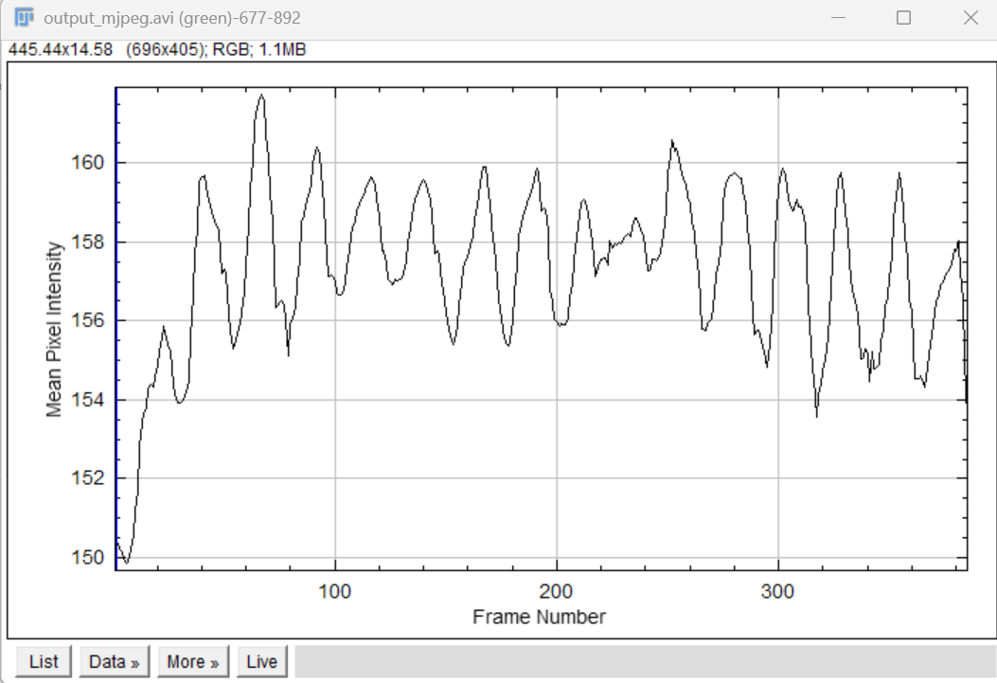
Mean pixel intensity (y-axis) , frame number (x-axis)
This is the raw pulse waveform
Reduce noise by smoothing the signal
Process – Smooth
Process – FFT – Bandpass Filter
Large structures down 3-4 pixels
Small structures up to 0 pixels
Supress stripes OFF
Autoscale OFF

Go to List – File – Save As – pulse_data.txt
= A2 / 30 if fps is 30
IMPORT INTO MATLAB
Open heartrate code

